PROJECT DESCRIPTION:
This system will be having two entities- admin and user. Both admin and user will access the same database in SQL Server to perform CRUD operations using Web API using HTTP methods like Get, Post, Put and Delete using Postman as a client.

SCOPE
The Loan Management System will be made on Visual Studio using ASP.Net Core project with Entity Framework, MVC and Web API will communicate with the database in SQL Server using Entity Framework. There will be a central database accessible by both user and admin. The user will be able to see their account details and will be able to update personal information like Mobile number, Address. The admin will be able to read, write, update and delete data from the database.

ENTITIES:
- Admin
- User

CONTROLLERS IMPLEMENTED:
- Admin
- User

FUNCTIONALITIES OF THE CONTROLLER:
- Admin
Admin is authorised to read, update or delete a record in the database and also add records.

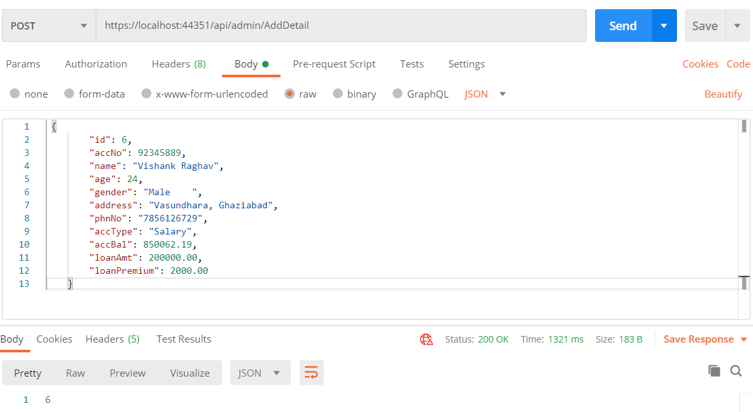
Fig: Admin adds a user record

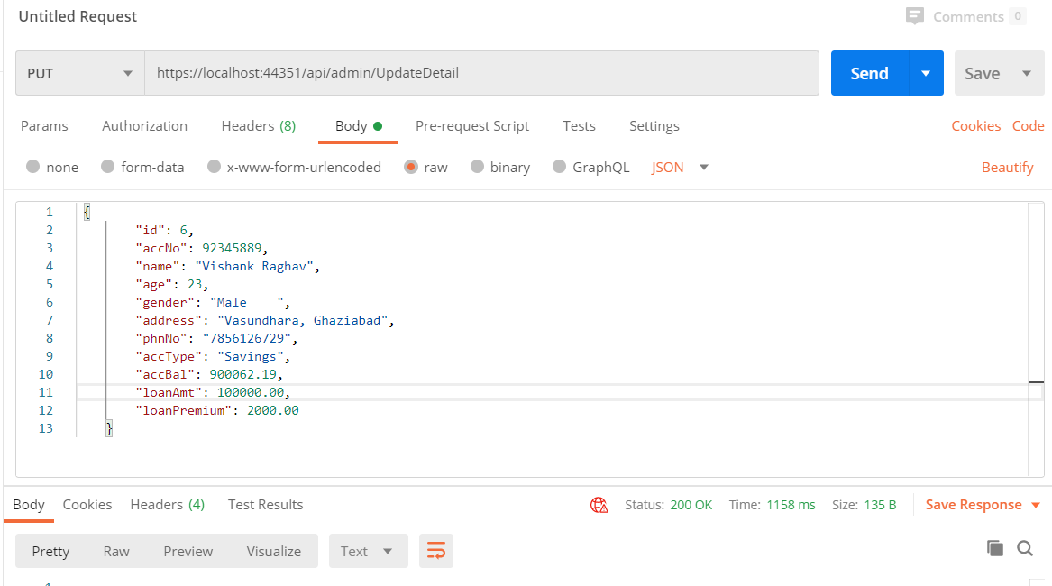
Fig: Admin updates the user details

- User
The user can access his details using known Id and can also update basic details like Address, Phone number.
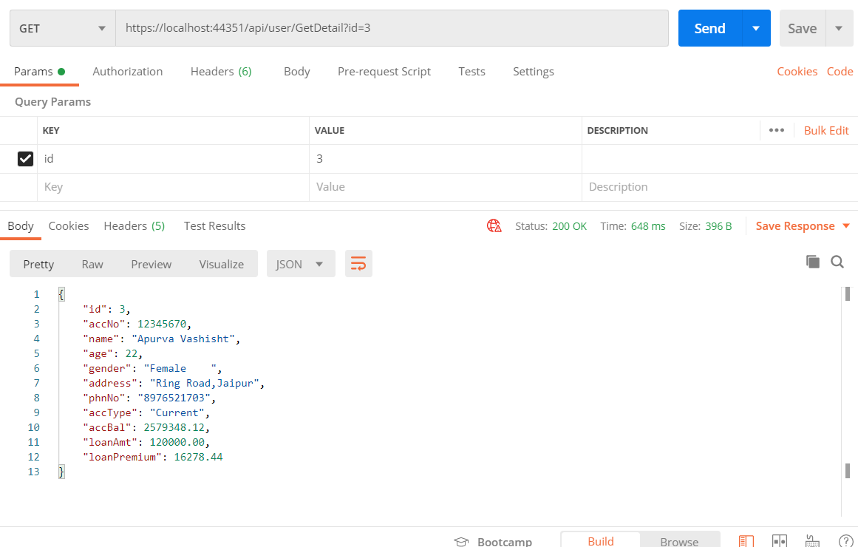
Fig: User accessing his detail using Id

SWAGGER DOCUMENTATION:
Swagger displays all the API methods used by admin controller and user controller to manipulate and access information from the database.
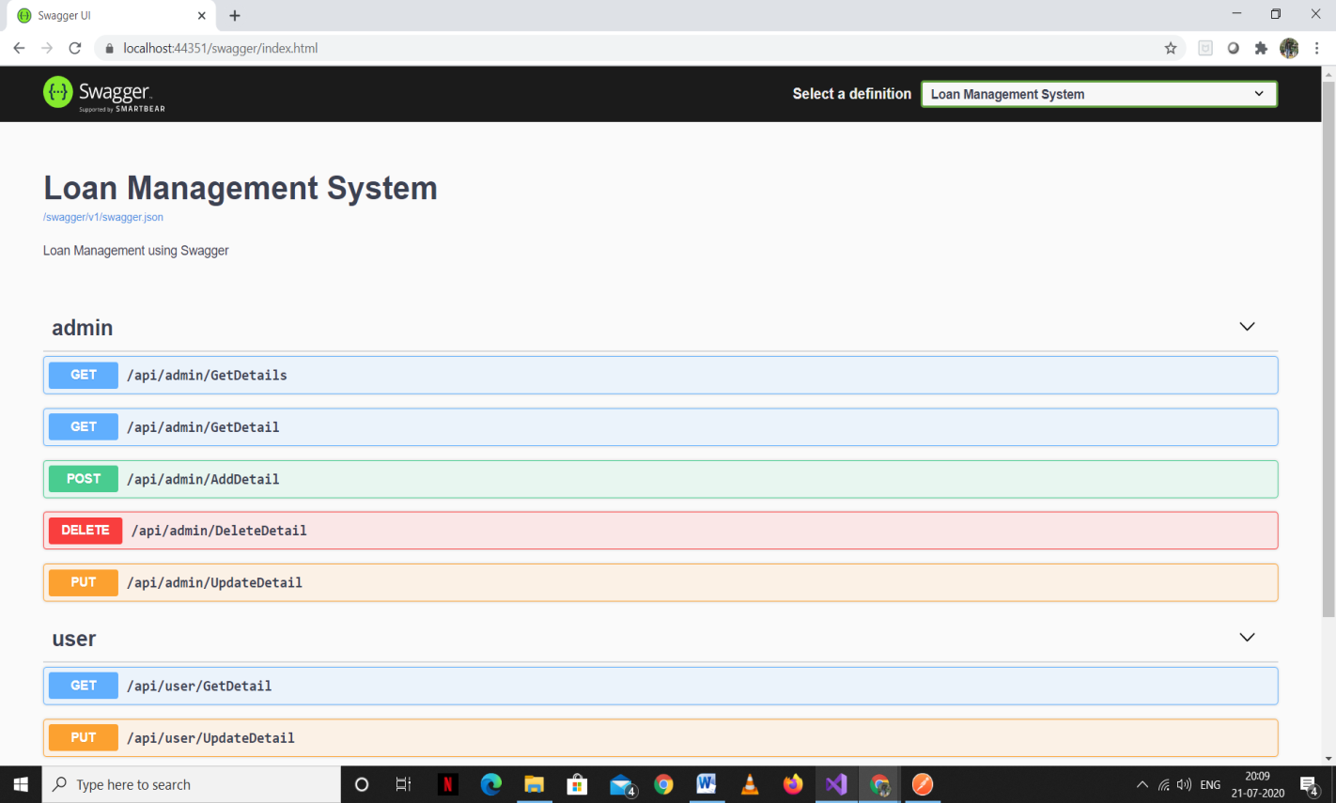

CONCLUSION:
With the help of Loan Management System the user can easily check his loan details like the amount of the loan and the premium of the loan. The admin can also check and perform CRUD operations using API with the help of controllers on the database to keep the data updated.

